# Current Requirement for IPs

## For PCIE

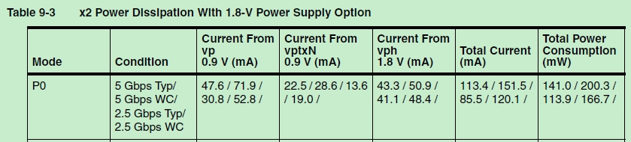

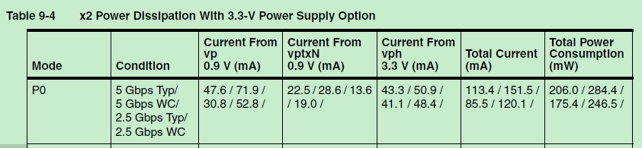

## For USB

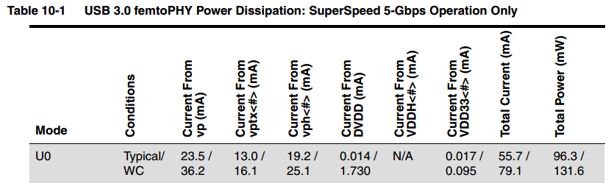

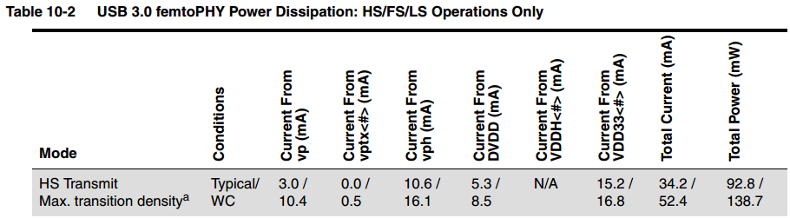

## For Typec

No information currently.

## For DDR

DDR_PLL_VDD current are 30mA for max

## CA7/CEVA/DDR PLL AVDD18

A7PLL/CEVA_PLL/DDRPLL AVDD18 current are all 5mA for max.